NLP assignment 1:

95.788%

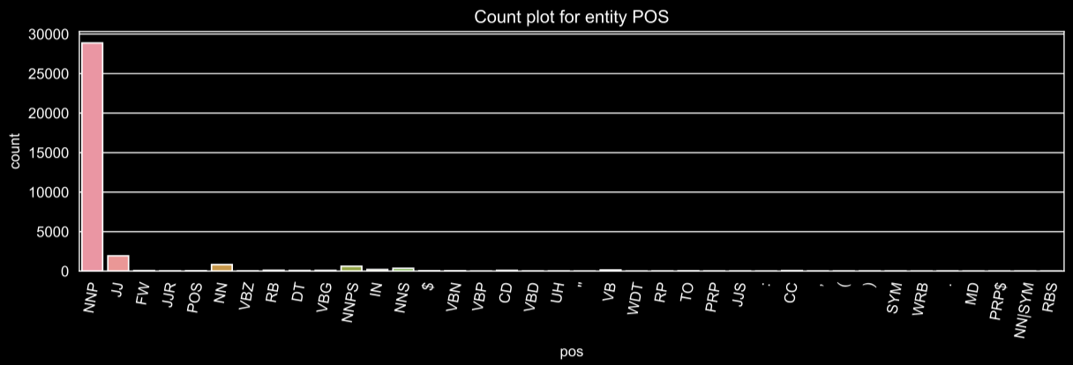

lambda sentence: [True if pos == 'NNP' else False for pos in sentence[1]]

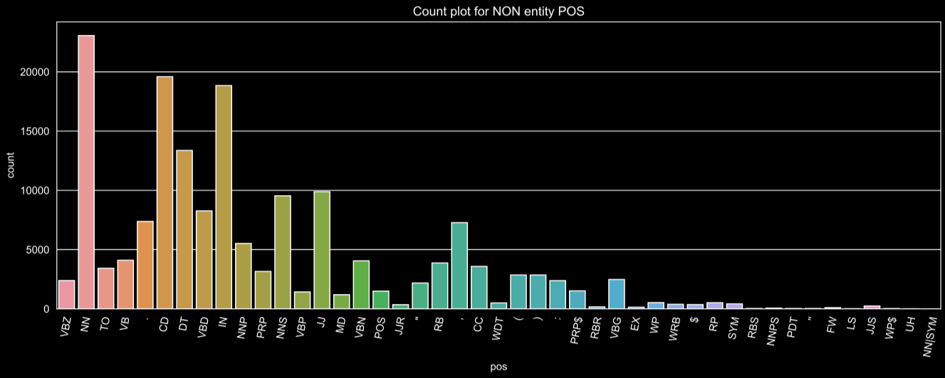

lambda sentence: [True if pos in ('NN', 'CD', 'IN', 'DT') else False for pos in sentence[1]]

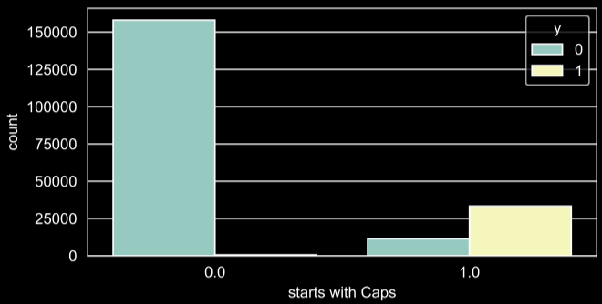

lambda sentence: [word[0].isupper() for word in sentence[0]]

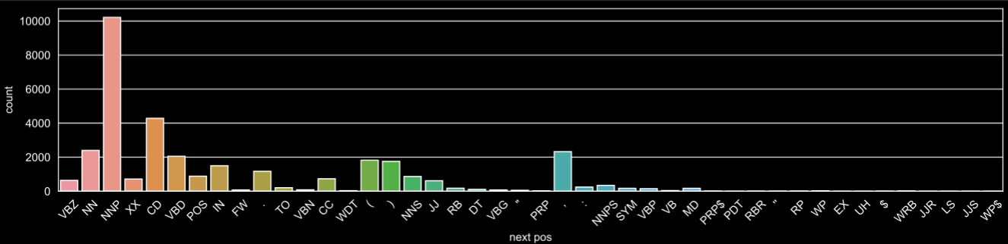

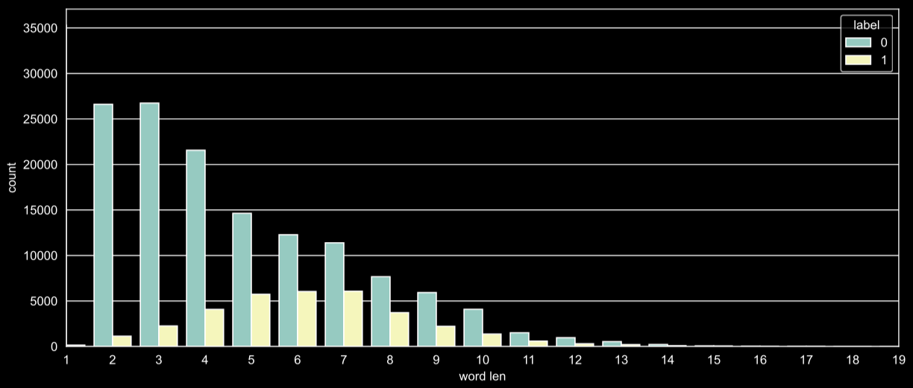

lambda sentence: [len(word) > 3 for word in sentence[0]]